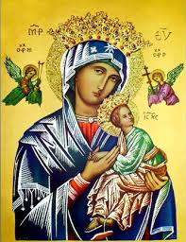**Our Lady of Perpetual Help Parish**

14 Castledare Place, Wilson 6107. **Telephone:** 9258 6003

**Email:** [Wilson@perthcatholic.org.au](mailto:Wilson@perthcatholic.org.au)

**Website:** www.wilsoncatholicchurch.org

**Parish Priest:** Reverend Father Greg D’Almeida.

**Email:**[gregory.dalmeida@perthcatholic.org.au](mailto:gregory.dalmeida@perthcatholic.org.au)

**Presbytery Telephone:** 9458 6586

**Parish Council and Rosters:** Lorraein O’Callaghan-Munt.

**Mobile Number:** 0417942854 **Email:** [Munt.pandL8@bigpond.com](mailto:Munt.pandL8@bigpond.com)

**Parish Safeguarding Officers:** Toto Olita and Rob Marshall

**Parish Newsletter:** Cliff Nunes**. Email:** cliffordgerard@bigpond.com

**Holy Saturday (Easter Vigil) Yr C and Easter Sunday 16th/17th April 2022**

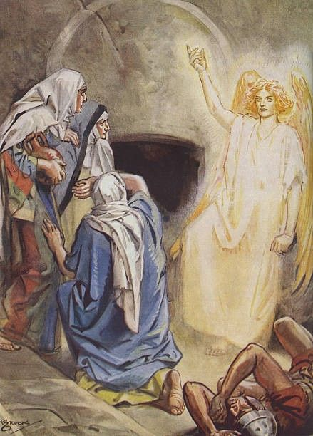

**Easter Vigil Gospel: Luke 24:1-12**  
*On the first day of the week, at the first sign of dawn, they went to the tomb with the spices they had prepared. They found that the stone had been rolled away from the tomb, but on entering discovered that the body of the Lord Jesus was not there. As they stood there not knowing what to think, two men in brilliant clothes suddenly appeared at their side. Terrified, the women lowered their eyes. But the two men said to them,* ***‘Why look among the dead for someone who is alive? He is not here; he has risen. Remember what he told you when he was still in Galilee: that the Son of Man had to be handed over into the power of sinful men and be crucified, and rise again on the third day?’*** *And they remembered his words.* ***When the women returned from the tomb they told all this to the Eleven and to all the others. The women were Mary of Magdala, Joanna, and Mary the mother of James. The other women with them also told the apostles, but this story of theirs seemed pure nonsense, and they did not believe them.*** *Peter, however, went running to the tomb. He bent down and saw the binding cloths but nothing else; he then went back home, amazed at what had happened.*

**Lighting and Blessing of the Paschal Candle**

The Paschal **Candle** or **Easter** **Candle** is a new **candle** which **is blessed and lit every year in the Church at the Easter Vigil.** **The candle represents Christ, “the light of the World”** and is used during the Paschal/**Easter** Season and also on special occasions such as Baptisms and Funerals. The candle would normally display several common symbols:

* **The Cross,** which is the most prominent symbol and most clearly identifies it as the Paschal candle.
* **The**[**Greek letters**](https://en.wikipedia.org/wiki/Greek_alphabet)[**alpha**](https://en.wikipedia.org/wiki/Alpha_(letter))**and**[**omega**](https://en.wikipedia.org/wiki/Omega_(letter)), which symbolize that God is the beginning and the end (from the [Book of Revelation](https://en.wikipedia.org/wiki/Book_of_Revelation)).
* **The year when the particular candle is being used**, which represents God amidst the present faithful/congregation.
* **Five grains of**[**incense**](https://en.wikipedia.org/wiki/Incense) (most often red), which are embedded in the candle during the Easter Vigil to represent the [five wounds of Jesus](https://en.wikipedia.org/wiki/Five_wounds_of_Jesus): the three nails that pierced his hands and feet, the spear thrust into his side, and the thorns that crowned his head.

The Easter candle is lit each day during Mass throughout the Paschal season, after the Pascal season the candle is positioned in the [sanctuary](https://en.wikipedia.org/wiki/Sanctuary) close to the [altar](https://en.wikipedia.org/wiki/Altar). The Paschal candle is also **lighted during**[**baptisms**](https://en.wikipedia.org/wiki/Baptism)to signify the [Holy Spirit](https://en.wikipedia.org/wiki/Holy_Spirit) promised to those who are baptised in Christ. The Paschal candle is also **lighted and placed near the**[**casket**](https://en.wikipedia.org/wiki/Casket)**during** **funeral services such as the Mass of Repose/Requiem.** This is to signify the hope of the resurrection into which Christians are baptised.

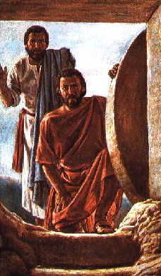**Easter Sunday Gospel John 20: 1-9**

*John’s gospel today tells us about the disciples' discovery of the empty tomb.*

Each of the Gospels tells us that Jesus' empty tomb was first discovered by women. In the case of John's Gospel, there is just one woman attending the tomb - Mary of Magdala. Mary is simply said to have observed that the stone that had sealed the tomb had been moved, and she runs to alert Simon Peter and the other disciple. Her statement to them is telling. She assumes that Jesus' body has been removed, perhaps stolen. She does not consider that Jesus has been raised from the dead. The disciples race to the tomb where they find an empty tomb with the burial cloths on the ground and the cloth used to cover Jesus’ head **“*rolled up in a place by itself*.”** The presence of the burial cloths in the tomb offers evidence that Jesus' body had not been stolen, as grave robbers would have taken the burial cloths together with the body, similarly, nor was Jesus’ body removed; so, the burial cloths in the empty tomb are significant (as they are physical evidence that Jesus’ body was not removed/stolen). “***Till this moment they had failed to understand the teaching of scripture, that he must rise from the dead.”***

**The Shroud of Turin**

The [Shroud of Turin](https://www.catholic.com/encyclopedia/holy-shroud) is an ancient burial cloth containing the front and back images of a scourged, crucified man whom many believe is [Jesus Christ](https://www.catholic.com/encyclopedia/jesus-christ). This relic, though blackened by age, bears the faint but distinct impress of a human [form](https://www.catholic.org/encyclopedia/view.php?id=4781) both back and front. If the marks we perceive were caused by human body, it is clear that the body was laid lengthwise along one half of the shroud while the other half was doubled back over the head to cover the whole front of the body from the face to the feet. Many of the faithful sincerely believe that the Shroud of Turin is the actual burial cloth of our Lord, Jesus Christ.  Pope John Paul II has clearly attested to the value of the Shroud.  For instance, in 1980, the Holy Father stated, ***“The Holy Shroud, is the most splendid relic of the passion and the resurrection.”***

“***The Shroud of Turin is either the most awesome and instructive relic of Jesus Christ in existence or it is one of the most ingenious, most unbelievably clever products of the human mind and hand on record. It is one or the other; there is no middle ground”*** (John Walsh, The Shroud, c. 1963).

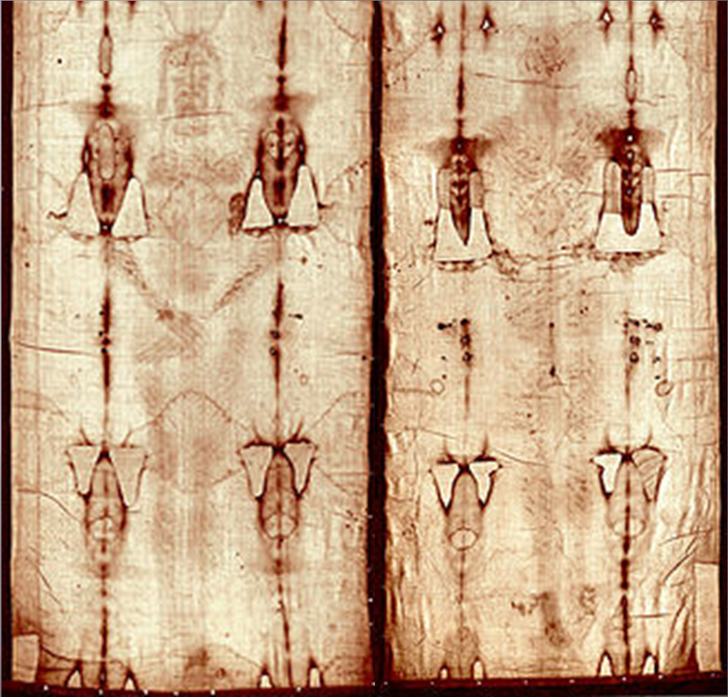

***For those who believe, no explanation is necessary; for those who do not,***

***no explanation is possible.***

**Our Parish Worship Schedule** A parish is a community of disciples of Jesus, who gather to celebrate the Mass and to “live the Gospel.” **We are a community of Jesus’ disciples** **and our church is here for our collective and individual worship and prayers.** We welcome the faithful to our Mass, or, to light a candle at our Marian chapel, or, to just pray in silence; and to grow spiritually.

**Mass Times** Mon, Tue, Wed, Thu & Fri 8.00 am (the Rosary after)

Saturday 6.00 pm

**Mass Times**  Sunday 9.30 am

**Reconciliation** Saturday night 5.15 – 5.45 pm

**Anointing of the Sick** Liaise with Fr Greg

**Baptisms, marriages and funerals** Liaise with Fr Greg

**Our Prayers of the Faithful**

In our parish prayers of the faithful, we pray to the Lord, to help and comfort our sick and suffering. We also pray for the souls of our recently departed, as well as, for those whose anniversaries, we remember at Mass today.

**Prayers for Our Sick and Suffering**

Crowley family**,** Joe Sundaram, Thilak, Diana Scully, Bluey Thompson**,** Celeste Vicensoni, Michael D’Souza, Glen Langan, Carla, Annette, Joe Gibson**,** Georgina and Ronnie Ghosh, Gemma Altieri, Fred Kara, Reg Brown, Mary & Derrick Jansen, Marie Webster Viola, Gerry and Maisie Prendergast, James Rydqvist, Annie Magdalena Rydqvist, Anne Rydqvist, Dr Andrew Chilufya Snr, Robbie Iliffe, Claire Webster, Donna Green, Horatio Hill, Vernon Thompson, Ilean Wright, Elham Nejaty, Cathy and Peter Ghouse, Jimmy Olivero, Kaye McIntyre, Alvin Desker, Jess Cable, Jeff and Tony Francis, Fr Andre, Sheila Vanwieringan, CD Joseph, Marina Lim, Joseph Fernandes, Wendy Price, Julie Pinto, Christopher Jaffer, Yianni Donato, Bonnie Sullivan, Joslyn De Sylva and Philomena Rodrigues.

**Prayers for our Recently Departed**

Terry Hogben and Glyn Ashley.

***“God blesses those people who grieve. They will find comfort.”* (Matthew 5:4).**

**Anniversaries of our Beloved Deceased**

Christaline Fernandes (14 Apr), Andrea Viola (14 Apr), Brenda Boswell (14 Apr), Alice Quinless (14 Apr), Seamas Munt (15 Apr), Elvis Jakait (15 Apr), Audrey Deniese (15 Apr), Joe Oorloff (16 Apr), Eunice Hickling (18 Apr), Jennifer Duxbury (19 Apr) and all our departed relatives and friends.

*Note: Parishioners may email Cliff at:* [*cliffordgerard@bigpond.com*](mailto:cliffordgerard@bigpond.com)*, for any additions (or deletions) to our lists of sick, recently deceased and anniversaries, whom you wish to be included in our “Prayers of the Faithful.”* ***Everyone has a name and if we are to pray for them - we should say their name.***

**Thank-you for the Palms**

***Our thanks to Harriet and Hubert Britto, for providing the palms for our Palm Sunday. The Britto family, have without fail, provided palms (for our Palm Sunday) to our parish for many years. Thank-you and Easter blessings to you from all parishioners.***

**Our Next Parish St Vincent de Paul Food Donations is to be 07th/08th May 2022**

Parishioners who may need a “helping hand,” may contact the SVDP Society for assistance, or, speak with our local SVDP representatives: **Bruno George (mobile: 0470571041**) at Wilson Parish, or **Sister Charla (telephone: 93545083)** at Riverton Parish. **The names of those requesting and receiving assistance is always confidential*.***

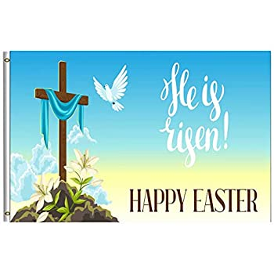**Happy Easter to Everyone**

Easter is the guarantee of our eternal life. Jesus assured Martha at the tomb of Lazarus: ***“I am the Resurrection and the life; whoever believes in Me will live even though he dies and whoever lives and believes in me***[***will***](https://www.catholic.org/encyclopedia/view.php?id=12332)***never die.” (John 11: 25-26)****.* 