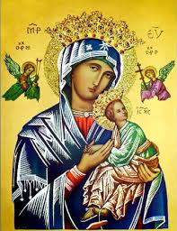**Our Lady of Perpetual Help Parish**

14 Castledare Place, Wilson 6107. **Telephone:** 9258 6003

**Email:** [Wilson@perthcatholic.org.au](mailto:Wilson@perthcatholic.org.au)

**Website:** www.wilsoncatholicchurch.org

**Parish Priest:** Reverend Father Greg D’Almeida.

**Email:**[gregory.dalmeida@perthcatholic.org.au](mailto:gregory.dalmeida@perthcatholic.org.au)

**Presbytery Telephone:** 9458 6586

**Parish Council and Rosters:** Lorraein O’Callaghan-Munt.

**Mobile Number:** 0417942854 **Email:** [Munt.pandL8@bigpond.com](mailto:Munt.pandL8@bigpond.com)

**Parish Safeguarding Officers:** Toto Olita and Rob Marshall

**Parish Newsletter:** Cliff Nunes**. Email:** cliffordgerard@bigpond.com

**5th Sunday of Easter. Year C. 15th May 2022**

**Gospel: John 13:31–35**

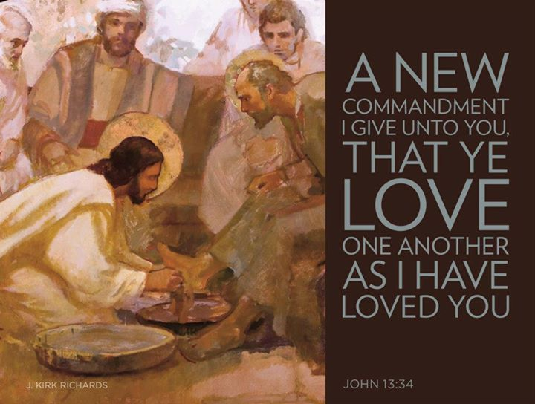***When Judas had gone*** *Jesus said: ‘Now has the Son of Man been glorified, and in him God has been glorified. If God has been glorified in him, God will in turn glorify him in himself, and will glorify him very soon. ‘My little children, I shall not be with you much longer. You will look for me, and, as I told the Jews, where I am going, you cannot come.* ***I give you a new commandment: love one another; just as I have loved you, you also must love one another. By this love you have for one another, everyone will know that you are my disciples.’***

**In Summary**

Today’s Gospel is Jesus speaking to the disciples at the Last Supper (after Judas has left to betray Jesus). **The love which Jesus speaks about, is the love shown by compassion, service and sacrifice.** It means overcoming anger, hatred and selfishness, as well as, fear, greed, jealousy and envy. **Jesus tells the disciples that everyone will know that they are His disciples because of the love they show for each other, and for others.**

**Christian love is the hallmark of Christianity and being a disciple of Jesus.** People will know that we are Christians by our love for one another and the love we have for others. **We see this love in the martyrs and saints, and also, in the loving example of those amongst us – the grandparents, parents, brothers and sisters, and all the women and men making small and large sacrifices, for each other and for others. When we live with this love, we show that we are disciples of Jesus and people will see (and know) that we are Christians!!**

*Jesus washing the feet of His disciples, is an example of Jesus showing His love for His disciples, and Jesus, suffering and dying on the Cross (for the eternal salvation of mankind) is an act of love for all.*

**Extract From Melbourne Archdiocese Summit: “The New Commandment of Love”**

The new commandment of love for one another becomes the defining principle and sign of discipleship. It is through this love for each other, which sets believers apart from the rest of the community, that people will know that they are followers of Jesus. This is much more difficult than it sounds! The biggest challenge is to act with love towards those we find it difficult to like!

**Love and the Commandments**

When someone asks Jesus, *"Which commandment in the Law is the greatest?"* Jesus replied: ***"You shall love the Lord your God with all your heart, and with all your soul, and with all your mind. This is the greatest and first commandment. And a second is like it: You shall love your neighbour as yourself. On these two commandments hang all the Law and the prophets.”***

From Jesus’ answer above, the Ten Commandments outlines how we live in fidelity and love with God (in the first three Commandments) and with all God’s people (in the remaining seven Commandments):

1. ***I am the Lord thy God and thou shalt not have any strange gods before me.***
2. ***Thou shalt not take the name of the Lord thy God in vain.***

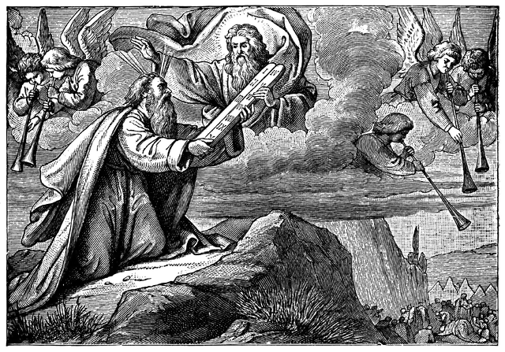

1. ***Remember to keep holy the Lord's day.***
2. ***Honour thy Father and Mother.***
3. ***Thou shalt not kill.***
4. ***Thou shalt not commit adultery.***
5. ***Thou shalt not steal.***
6. ***Thou shalt not bear false witness against thy neighbour.***
7. ***Thou shalt not covet thy neighbour’s wife.***
8. ***Thou shalt not covet thy neighbour’s goods.***

It was in the 15th Century that the Ten Commandments were listed in the present form; expressing the commandments in a “rhymed” fashion, to make them easier to memorize and understand, as well as, using the positive form like: “*thou shall not,” “remember”* and *“honour*.”

**Note:** The Catechism of the Catholic Church (CCC) 2066 states:***“The division and numbering of the Commandments have varied in the course of history. The present catechism follows the division of the Commandments established by St Augustine, which has become traditional in the Catholic Church. It is also that of the Lutheran confessions. The Greek Fathers worked out a slightly different division, which is found in the Orthodox Churches and Reformed communities.”***

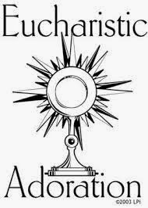**Thursday 19th May 24-Hour Perpetual Adoration at Our Parish**

**Jesus Youth Australia is hosting “Hours of Grace 2022,” which is a perpetual adoration event which occurs every year from Ash Wednesday to Pentecost**. **It is being held in our parish from 8am, Thu 19th May, to 8am, Fri 20th May. All parishioners are invited to join in this personal adoration to our Lord. Kindly include your name on the roster at the rear of the church, to be part of this 24-hour perpetual adoration to Our Lord. POC: Benny (Jesus Youth) at 0469 663 396.**

*The exposition of the Holy Eucharist at the altar, is Jesus standing at the altar to receive and listen to our individual and personal prayers. Jesus Youth is an international association within the Catholic Church with a focus on evangelising.* ***One of it’s aims is to help people to have a personal relationship with Christ and to experience the love of the Father and the guidance of the Holy Spirit in our lives.***

**Our Parish Worship Schedule** A parish is a community of disciples of Jesus, who gather to celebrate the Mass and to “live the Gospel.” **We are a community of Jesus’ disciples** **and our church is here for our collective and individual worship and prayers.** We welcome the faithful to our Mass, or, to light a candle at our Marian chapel, or, to just pray in silence; and to grow spiritually.

**Mass Times** Mon, Tue, Wed, Thu & Fri 8.00 am (the Rosary after)

Saturday 6.00 pm

**Mass Times**  Sunday 9.30 am

**Reconciliation** Saturday night 5.15 – 5.45 pm

**Anointing of the Sick** Liaise with Fr Greg

**Baptisms, marriages and funerals** Liaise with Fr Greg

**Our Prayers of the Faithful**

In our parish prayers of the faithful, we pray to the Lord, to help and comfort our sick and suffering. We also pray for the souls of our recently departed, as well as, for those whose anniversaries, we remember at Mass today.

**Prayers for Our Sick and Suffering**

Celia, Crowley family**,** Joe Sundaram, Thilak, Diana Scully, Bluey Thompson**,** Celeste Vicensoni, Michael D’Souza, Carla, Annette, Joe Gibson**,** Georgina and Ronnie Ghosh, Gemma Altieri, Fred Kara, Reg Brown, Mary & Derrick Jansen, Marie Webster Viola, Gerry and Maisie Prendergast, James Rydqvist, Annie Magdalena Rydqvist, Anne Rydqvist, Dr Andrew Chilufya Snr, Robbie Iliffe, Claire Webster, Donna Green, Horatio Hill, Vernon Thompson, Ilean Wright, Elham Nejaty, Cathy and Peter Ghouse, Jimmy Olivero, Kaye McIntyre, Alvin Desker, Jess Cable, Jeff and Tony Francis, Fr Andre, Sheila Vanwieringan, CD Joseph, Marina Lim, Joseph Fernandes, Wendy Price, Julie Pinto, Christopher Jaffer, Yianni Donato, Bonnie Sullivan, Joslyn De Sylva and Philomena Rodrigues.

**Prayers for our Recently Departed**

**Kerry Wimbridge, Glen Langan, Eugene Marie, Felice Palumbo** and Kunjachan Kalloor.

**Anniversaries of our Beloved Deceased**

Alfredo Gomes (14 May), Elizabeth Lewis (15 May), Ronald Jaffer (15 May), Pascal Lobo (16 May), Jacob Paries (16 May) and all our departed relatives and friends.

***Note:*** *Parishioners may email Cliff at:* [*cliffordgerard@bigpond.com*](mailto:cliffordgerard@bigpond.com)*, for any additions (or deletions) to our lists of sick, recently deceased and anniversaries, whom you wish to be included in our “Prayers of the Faithful.”* ***Everyone has a name and if we are to pray for them - we should say their name.***

**04th/5th June is Our Next Parish St Vincent de Paul Donations**

***Thank-you to everyone who donates to this worthy charity, which helps those in our community who need a helping hand!!***

Parishioners who may need a “helping hand,” may contact the SVDP Society for assistance, or speak with our local SVDP representatives: **Bruno George (mobile: 0470571041**) at Wilson Parish, or **Sister Charla (telephone: 93545083)** at Riverton Parish. **The names of those requesting and receiving assistance is always confidential*.***