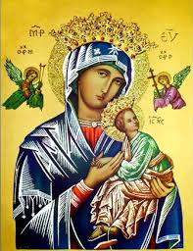**Our Lady of Perpetual Help Parish**

14 Castledare Place, Wilson 6107. **Telephone:** 9258 6003

**Email:** [Wilson@perthcatholic.org.au](mailto:Wilson@perthcatholic.org.au)

**Website:** www.wilsoncatholicchurch.org

**Parish Priest:** Reverend Father Greg D’Almeida.

**Email:**[gregory.dalmeida@perthcatholic.org.au](mailto:gregory.dalmeida@perthcatholic.org.au)

**Presbytery Telephone:** 9458 6586

**Parish Council and Rosters:** Lorraein O’Callaghan-Munt.

**Mobile Number:** 0417942854 **Email:** [Munt.pandL8@bigpond.com](mailto:Munt.pandL8@bigpond.com)

**Parish Safeguarding Officers:** Toto Olita and Rob Marshall

**Parish Newsletter:** Cliff Nunes**. Email:** cliffordgerard@bigpond.com

**3rd Sunday of Easter. Year C. 01st May 2022**

**Gospel: John 21:1–19**

***Jesus showed himself again to the disciples. It was by the Sea of Tiberias, and it happened like this: Simon Peter, Thomas called the Twin, Nathanael from Cana in Galilee, the sons of Zebedee and two more of his disciples were together.*** *Simon Peter said, ‘I’m going fishing.’ They replied, ‘We’ll come with you.’ They went out and got into the boat but caught nothing that night. It was light by now and there stood Jesus on the shore, though the disciples did not realise that it was Jesus. Jesus called out, ‘Have you caught anything, friends?’ And when they answered, ‘No’, he said, ‘Throw the net out to starboard and you’ll find something.’ So they dropped the net, and there were so many fish that they could not haul it in.* ***The disciple Jesus loved*** *said to Peter, ‘It is the Lord.’ At these words ‘It is the Lord’, Simon Peter, who had practically nothing on, wrapped his cloak round him and jumped into the water. The other disciples came on in the boat, towing the net and the fish; they were only about a hundred yards from land.*

*As soon as they came ashore they saw that there was some bread there, and a charcoal fire with fish cooking on it. Jesus said, ‘Bring some of the fish you have just caught.’ Simon Peter went aboard and dragged the net to the shore, full of big fish, one hundred and fifty-three of them; and in spite of there being so many the net was not broken. Jesus said to them, ‘Come and have breakfast.’ None of the disciples was bold enough to ask, ‘Who are you?’; they knew quite well it was the Lord. Jesus then stepped forward, took the bread and gave it to them, and the same with the fish.* ***This was the third time that Jesus showed himself to the disciples after rising from the dead. After the meal Jesus said to Simon Peter, ‘Simon son of John, do you love me more than these others do?’ He answered, ‘Yes Lord, you know I love you.’ Jesus said to him, ‘Feed my lambs.’ A second time he said to him, ‘Simon son of John, do you love me?’ He replied, ‘Yes, Lord, you know I love you.’ Jesus said to him, ‘Look after my sheep.’ Then he said to him a third time, ‘Simon son of John, do you love me?’ Peter was upset that he asked him the third time, ‘Do you love me?’ and said, ‘Lord, you know everything; you know I love you.’ Jesus said to him, ‘Feed my sheep.***

*‘I tell you most solemnly, when you were young you put on your own belt and walked where you liked; but when you grow old you will stretch out your hands, and somebody else will put a belt round you and take you where you would rather not go.****’ In these words he indicated the kind of death by which Peter would give glory to God. After this he said, ‘Follow me.’***

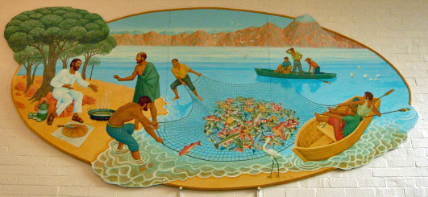

**In Summary**

**This gospel includes three scenes:** the extraordinary catch of fish; the meal on the shore (with obvious eucharistic overtones); and the dialogue with Peter (Simon Peter/Simon, son of John) which reinforces Peter’s blessing, as the leader of the flock.

**The great catch of fish,** indicates that the Good News of the Gospel, will take root and bring many converts to the faith, as well as, it reaffirms the impending mission of the apostles: **“*Come after me and I***[***will***](https://www.catholic.org/encyclopedia/view.php?id=12332)***make you fishers of people,*”** *Matthew 4:19*.

**The open-air meal** indicates that Jesus (even after His death on the Cross) continues to nourish His disciples. When we gather for Mass, we too are nourished by Jesus in the bread and wine - the Eucharist becomes His Body and Blood, and **feeds us spiritually**.

**Jesus’ dialogue with Peter** reaffirms Jesus’ confidence in Peter (after Peter’s denial of Jesus) and reinforces Peter’s role as the leader of the disciples. Peter is thus our first leader (Pope) and is entrusted to: “***Feed my lambs, look after my sheep*** and ***feed my sheep.”*** The role of Peter, as the leader of Jesus’ disciples has been handed down in succession to the Popes (*Francis is the 266th Pope*). *We are disciples of Jesus.*

**The “disciple Jesus loved” and Peter’s “mission statement”**

1. John is the “***disciple Jesus loved”*** in this gospel reading*.* **This description is only found in John’s Gospel** and John chooses to use these words rather than, me or I.**Peter, James and John**, were the three who would witness the Transfiguration and later, the agony of Jesus at Gethsemane. Of the eleven disciples at the time of the Crucifixion, **only John was at the Cross, and Jesus would entrust His mother, Mary, to the care of John.** So, this (perhaps) explains why John indulgences himself by using the description, the “***disciple Jesus loved,”* to describe “his” place, in “his” gospel.**
2. **Jesus’ final “mission statement” to Peter,** the first Pope of Jesus’ church on earth is clear and concise: “***Feed my lambs, look after my sheep,*** and, *f****eed my sheep:”***

* **The lambs** are those yet to be baptised. This tasks the Church to evangelise and to spread the Word of God. **Feed is to nourish spiritually.**
* **“Look after my sheep**,” tasks the Church to care and to tend to the needs of the faithful (the sheep/the baptised).
* **“Feed my sheep,”** tasks the Church to nourish (spiritually) the faithful.

***In ten words Jesus has clearly explained the role of the Pope and the tasks of the Church, through the ages.***

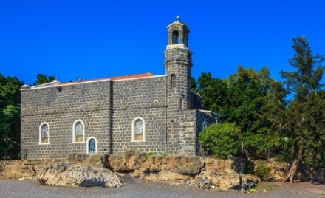

**Meanwhile in the Holy Land**

**The Church of the Primacy of Peter**, is a Franciscan church built on the ruins of an earlier 4th Century church, on the NW shore of the Sea of Galilee (aka Sea of Tiberias). It commemorates, and allegedly marks the spot, where the resurrected Christ met with Peter and the other disciples. It is called the Primacy of Peter because it is on this occasion, that Jesus reaffirmed Peter as the leader of the disciples and His church on earth. Every newly installed Pope (in modern times since Pope Paul VI in 1964) have visited this site. Nearby is the Mount of Beatitudes, as well as, the Church of the Multiplication (of the fish and bread). Further north is Capernaum. **This is our Holy Land.**

**Our Parish Worship Schedule** A parish is a community of disciples of Jesus, who gather to celebrate the Mass and to “live the Gospel.” **We are a community of Jesus’ disciples** **and our church is here for our collective and individual worship and prayers.** We welcome the faithful to our Mass, or, to light a candle at our Marian chapel, or, to just pray in silence; and to grow spiritually.

**Mass Times** Mon, Tue, Wed, Thu & Fri 8.00 am (the Rosary after)

Saturday 6.00 pm

**Mass Times**  Sunday 9.30 am

**Reconciliation** Saturday night 5.15 – 5.45 pm

**Anointing of the Sick** Liaise with Fr Greg

**Baptisms, marriages and funerals** Liaise with Fr Greg

**Our Prayers of the Faithful**

In our parish prayers of the faithful, we pray to the Lord, to help and comfort our sick and suffering. We also pray for the souls of our recently departed, as well as, for those whose anniversaries, we remember at Mass today.

**Prayers for Our Sick and Suffering**

**Celia,** Crowley family**,** Joe Sundaram, Thilak, Diana Scully, Bluey Thompson**,** Celeste Vicensoni, Michael D’Souza, Glen Langan, Carla, Annette, Joe Gibson**,** Georgina and Ronnie Ghosh, Gemma Altieri, Fred Kara, Reg Brown, Mary & Derrick Jansen, Marie Webster Viola, Gerry and Maisie Prendergast, James Rydqvist, Annie Magdalena Rydqvist, Anne Rydqvist, Dr Andrew Chilufya Snr, Robbie Iliffe, Claire Webster, Donna Green, Horatio Hill, Vernon Thompson, Ilean Wright, Elham Nejaty, Cathy and Peter Ghouse, Jimmy Olivero, Kaye McIntyre, Alvin Desker, Jess Cable, Jeff and Tony Francis, Fr Andre, Sheila Vanwieringan, CD Joseph, Marina Lim, Joseph Fernandes, Wendy Price, Julie Pinto, Christopher Jaffer, Yianni Donato, Bonnie Sullivan, Joslyn De Sylva and Philomena Rodrigues.

**Prayers for our Recently Departed**

**Kunjachan Kalloor,** Terry Hogben and Glyn Ashley.

**Anniversaries of our Beloved Deceased**

Sabino Altieri (28 Apr), Edith McIntyre (28 Apr), Ivan Fitzgerald (28 Apr), John Heng (28 Apr), Dominic Teo (29 Apr), Philip Tan (29 Apr), Tess Glennon (29 Apr), Deryck Woodford (30 Apr), **Noreen Perry (01 May),** Maria Boin (03 May), Eda Colasante (03 May), Angelo Spadano (03 May), **Douglas Miller (04 May)** and all our departed relatives and friends.

***Note:*** *Parishioners may email Cliff at:* [*cliffordgerard@bigpond.com*](mailto:cliffordgerard@bigpond.com)*, for any additions (or deletions) to our lists of sick, recently deceased and anniversaries, whom you wish to be included in our “Prayers of the Faithful.”* ***Everyone has a name and if we are to pray for them - we should say their name.***

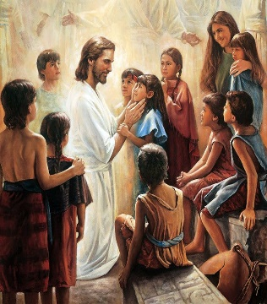**We Welcome “God’s Little Children” to Our Mass**

*People were bringing little children to Jesus to have him touch them, but the disciples rebuked them. When Jesus saw this, he was indignant. He* *said to them,* ***“Let the little children come to me, and do not hinder them, for the kingdom of God belongs to such as these.”***Mk 10: 13-14.

**Note:** Activity sheets and colour pencils, are available at the rear of the church, to occupy the children during Mass. Parents may even pin their child’s work on the noticeboard (when space is available) for others to appreciate their efforts.

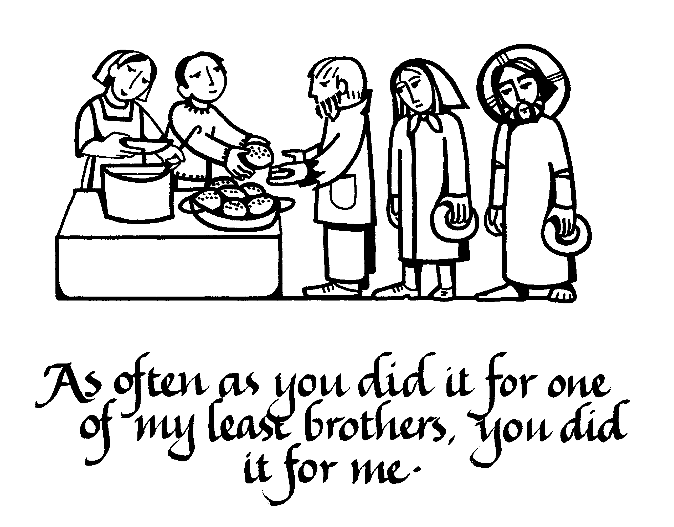**Next Weekend is Our Parish St Vincent de Paul Food Donations**

***Food donations may be left at the rear of the church, or at our parish centre. Cash donations may be deposited in the “Poor Box” at the entrance to the church***

Parishioners who may need a “helping hand,” may contact the SVDP Society for assistance, or speak with our local SVDP representatives: **Bruno George (mobile: 0470571041**) at Wilson Parish, or **Sister Charla (telephone: 93545083)** at Riverton Parish. **The names of those requesting and receiving assistance is always confidential*.***

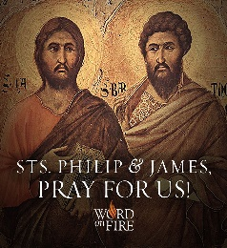

**Tuesday 02 May is the Feast Day of the Apostles Phillip and James (the less)**

Their relics rest together in the church of the Holy Apostles in Rome.