**Our Lady of Perpetual Help Parish**

14 Castledare Place, Wilson 6107. **Telephone:** 9258 6003

**Email:** [Wilson@perthcatholic,org.au](mailto:Wilson@perthcatholic,org.au)

**Parish Priest:** Reverend Father Greg D’Almeida.

**Email:**[gregory.dalmeida@perthcatholic.org.au](mailto:gregory.dalmeida@perthcatholic.org.au)

**Presbytery Telephone:** 9458 6586

**Parish Council and Rosters:** Lorraein O’Callaghan-Munt.

**Mobile Number:** 0417942854 **Email:** [Munt.pandL8@bigpond.com](mailto:Munt.pandL8@bigpond.com)

**Parish Safeguarding Officers:** Toto Olita and Rob Marshall

**Parish Newsletter:** Cliff Nunes**. Email:** cliffordgerard@bigpond.com

**3rd Sunday in Lent. Year C. 20th March 2022**

**Gospel: Luke 13: 1-9**

*Some people arrived and told Jesus about the Galileans whose blood Pilate had mingled with that of their sacrifices. At this he said to them, ‘Do you suppose these Galileans who suffered like that were greater sinners than any other Galileans? They were not, I tell you. No; but unless you repent you will all perish as they did. Or those eighteen on whom the tower at Siloam fell and killed them? Do you suppose that they were more guilty than all the other people living in Jerusalem? They were not, I tell you. No; but unless you repent you will all perish as they did.’*

*He told this parable: ‘A man had a fig tree planted in his vineyard, and he came looking for fruit on it but found none. He said to the man who looked after the vineyard, “Look here, for three years now I have been coming to look for fruit on this fig tree and finding none. Cut it down: why should it be taking up the ground?” “Sir,” the man replied “leave it one more year and give me time to dig round it and manure it: it may bear fruit next year; if not, then you can cut it down.”’*

**In Summary**

**This gospel is really about the loving care and patience of God.** It was commonly believed that a loving God could not be responsible for terrible calamities that befell people, but that these events must somehow be a result of their own sinfulness. Jesus takes the opportunity to say that the recent deaths of both Galileans and inhabitants of Jerusalem did not mean that they were any more sinful than others. They were no more deserving of death than anyone else. Indeed, we must not look to the sinfulness of others but to our own need for repentance. The parable of the owner of the vineyard tells of **God’s infinite patience in dealing with the sinfulness of humans.** **Despite our failings, God will graciously allow us time to produce our best fruit.** The theme of this gospel—God’s forgiveness and care—will be taken up in the gospels of the next two weeks. (*From The Summit Online at: www.melbournecatholic.org)*

**In Conclusion**

In today’s gospel, Jesus continues on His journey to Jerusalem. During this journey, Jesus preaches to the people and also, prepares His disciples for the trials and tribulations to come. However, Jesus must also respond to those who question and challenge His authority and actions.

Luke tells us that some among the crowd, report of a massacre of Galileans by Pilate. The crowd seem to be asking Jesus to explain why these people suffered. Many believed that suffering was a punishment from God for sins committed. However, Jesus explains that those who were massacred were no more or less sinful, than those present, and that it must not be interpreted as God’s punishment for sin. Rather, **God calls us to repent for our sins because God is merciful.**

Jesus then tells a parable, to explain God's patience and His hopefulness for us. The parable contrasts the patience and hopefulness of the gardener with the impatient property owner. When told to cut down the fig tree because it is not producing fruit, the gardener urges patience. If properly tended, the barren fig tree may yet bear fruit. **God is patient, and** **we will we be judged by “the fruit” we bear.**



**So, God refuses to abandon us, He chooses to attend to us because He is merciful, and hopeful that we will “bear good fruit.”** Next week's Gospel (*the parable of the Prodigal Son*) will give an example of God’s love and forgiveness.

**Parish Lenten Program**

**The virtues of prayer, fasting and almsgiving are at the heart of our Lenten experience**. Through **prayer** we are drawn closer to God so that we are better able to realise our baptismal promise to live as Jesus teaches us. **Fasting** joins us in solidarity with the poor who often have no choice but to live without food. **Almsgiving** is a sign of our commitment to others and our compassion. **During Lent, we remember our vows to reject sin and to be disciples of Jesus.**

|  |  |
| --- | --- |
| **DATE** | **EVENT & TIME (PC = Project Compassion)** |
| **20th March** | 3rd Sun of Lent. **PC: In Australia.** *Caritas Australia helps to preserve and assist our local aboriginal arts and culture.* |
| **27th March** | 4th Sun of Lent. **PC: In** **the DRC (Congo).** *Caritas Australia supports and assist people, to create a better future for their family and the community.* |
| **03rd April** | 5th Sun of Lent. **PC: In Solomon Islands.** *Caritas Australia helps the young with education, as well as, training for adult employment.* |
| **10th April** | **PASSION/PALM Sunday. PC:** *2022 Project Compassion donations are to be used to help ensure a better future for the needy.* |
| **14th April** | **HOLY THURSDAY**  **6.00 pm Washing of the Feet & Last Supper** |
| **15th April** | **GOOD FRIDAY** *Special collection for our Holy Land*  **Stations of the Cross 10am**  **The Passion of Christ 3pm** |
| **16th April** | **HOLY SATURDAY**  **“Lighting the Easter Fire/Candle.”** |
| **17th April** | **EASTER SUNDAY 9.30am** |

***Note: Stations of the Cross Every Friday at 6pm during Lent and 10am on Good Friday***

**2022 Project Compassion Week Three – Helping People in Australia**

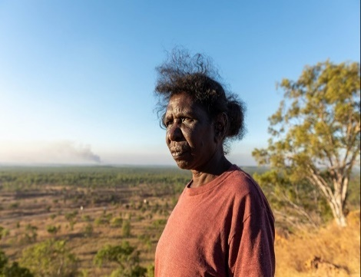 Janice is a Wagilak woman, who lives in Arnhem Land. Like many remote communities in the Northern Territory, Janice’s faces a range of challenges – low employment and education, financial hardship, poorer health and lower life expectancy. She is a traditional dancer who tells stories through movements handed down over generations. **With Caritas Australia support**, Janice and the Djilpin Arts Aboriginal Corporation support the community to generate income and employment, whilst keeping their culture alive.

**Our Parish Worship Schedule** A parish is a community of disciples of Jesus, who gather to celebrate the Mass and to “live the Gospel.” **We are a community of Jesus’ disciples** **and our church is here for our collective and individual worship and prayers.** We welcome the faithful to our Mass, or, to light a candle at our Marian chapel, or, to just pray in silence; and to grow spiritually.

**Mass Times** Mon, Tue, Wed, Thu & Fri 8.00 am (the Rosary after)

Saturday 6.00 pm

**Mass Times**  Sunday 9.30 am

**Reconciliation** Saturday night 5.15 – 5.45 pm

**Anointing of the Sick** Liaise with Fr Greg

**Baptisms, marriages and funerals** Liaise with Fr Greg

**Our Prayers of the Faithful**

In our parish prayers of the faithful, we pray to the Lord, to help and comfort our sick and suffering. We also pray for the souls of our recently departed, as well as, for those whose anniversaries, we remember at Mass today.

**Prayers for Our Sick and Suffering**

Crowley family**,** Joe Sundaram, Thilak, Diana Scully, Bluey Thompson**,** Celeste Vicensoni, Michael D’Souza, Glen Langan, Carla, Annette, Joe Gibson**,** Georgina and Ronnie Ghosh, Gemma Altieri, Fred Kara, Reg Brown, Mary & Derrick Jansen, Terry Hogben, Marie Webster Viola, Gerry and Maisie Prendergast, James Rydqvist, Annie Magdalena Rydqvist, Anne Rydqvist, Dr Andrew Chilufya Snr, Robbie Iliffe, Claire Webster, Donna Green, Horatio Hill, Vernon Thompson, Ilean Wright, Elham Nejaty, Cathy and Peter Ghouse, Jimmy Olivero, Kaye McIntyre, Alvin Desker, Jess Cable, Jeff and Tony Francis, Fr Andre, Sheila Vanwieringan, CD Joseph, Marina Lim, Joseph Fernandes, Wendy Price, Julie Pinto, Christopher Jaffer, Yianni Donato, Bonnie Sullivan, Joslyn De Sylva and Philomena Rodrigues.

**Prayers for our Recently Departed**

George Dourado**,** Teresa Borthwick and Ruth Gemmy**.**

***“God blesses those people who grieve. They will find comfort.”* (Matthew 5:4).**

**Anniversaries of our Beloved Deceased**

**Arthur Nunes (17 Mar),** Bob Weir (17 Mar), Wendy Blake (17 Mar), Cristina Patullo (18 Mar), Corinne Wakefield (18 Mar), **Dr Eugene Aviet (19 Mar)**, Stansilas Paries (19 Mar), Mary Castelino (19 Mar), **Roy Paley (19 Mar),** Virginia Jewers (19 Mar), Paul Travers (20 Mar), Bernie Long (23 Mar) and all our departed relatives and friends.

**“God loved the world so much he gave us his only Son, so that everyone who believes in him may not be lost but may have eternal life” (John 3:16).**

***Note:*** *Parishioners may email Cliff at:* [*cliffordgerard@bigpond.com*](mailto:cliffordgerard@bigpond.com)*, for any additions (or deletions) to our lists of sick, recently deceased and anniversaries, whom you wish to be included in our “Prayers of the Faithful.”* ***Everyone has a name and if we are to pray for them - we should say their name.***

**We Welcome “God’s Little Children” to Our Mass**

*People were bringing little children to Jesus to have him touch them, but the disciples rebuked them. When Jesus saw this, he was indignant. He* *said to them,* ***“Let the little children come to me, and do not hinder them, for the kingdom of God belongs to such as these.”***Mark 10: 13-14.

Activity sheets and colour pencils, are available at the rear of the church, to occupy the children during Mass. Parents may even pin their child’s work on the noticeboard (when space is available) for others to appreciate their efforts.

**02nd/03rd April is to be our Next Parish St Vincent de Paul Food Donations**

For parishioners who may wish to contribute to this worthy program, any non-perishable food in tins, packets or boxes will do (but no glass please). In addition to a food hamper, a $30 Woolworths voucher is usually provided to enable the purchase of essentials like; fresh fruit and vegetables, baby food and more. **Cash donations may be deposited in our SVDP/poor donation box at the entrance of the church,** to enable the purchase of cash vouchers.

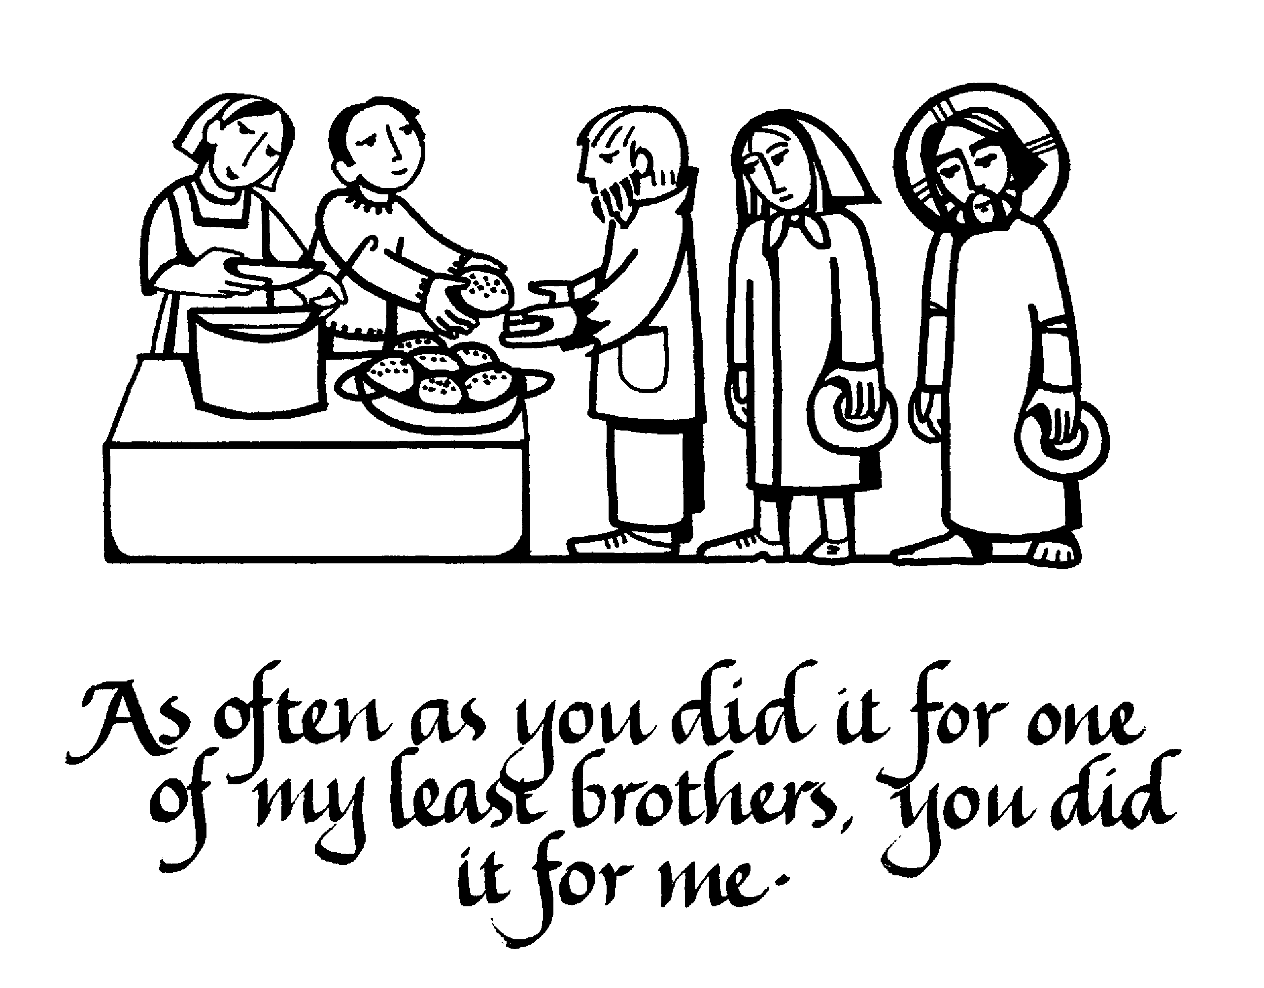

*The King will reply,* ***'Truly I tell you, whatever you did for one of the least of these brothers and sisters of mine, you did for me.****' "Then he will say to those on his left, 'Depart from me, you who are cursed, into the eternal fire prepared for the devil and his angels. For I was hungry and you gave me nothing to eat, I was thirsty and you gave me nothing to drink, I was a stranger and you did not invite me in, I needed clothes and you did not clothe me, I was sick and in prison and you did not look after me.” They also will answer, 'Lord, when did we see you hungry or thirsty or a stranger or needing clothes or sick or in prison,* ***and*** *did not help you?" He will reply,* ***'Truly I tell you, whatever you did not do for one of the least of these, you did not do for me.'*** *(Matthew 25: 40-45).*

Parishioners who may need a “helping hand,” may contact the SVDP Society for assistance, or speak with our local SVDP representatives: **Bruno George (mobile: 0470571041**) at Wilson Parish, or **Sister Charla (telephone: 93545083)** at Riverton Parish. **The names of those requesting and receiving assistance is always confidential*.***