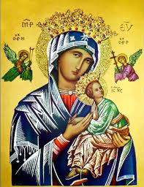**Our Lady of Perpetual Help Parish**

14 Castledare Place, Wilson 6107. **Telephone:** 9258 6003

**Email:** [Wilson@perthcatholic,org.au](mailto:Wilson@perthcatholic,org.au)

**Parish Priest:** Reverend Father Greg D’Almeida.

**Email:**[gregory.dalmeida@perthcatholic.org.au](mailto:gregory.dalmeida@perthcatholic.org.au)

**Presbytery Telephone:** 9458 6586

**Parish Council and Rosters:** Lorraein O’Callaghan-Munt.

**Mobile Number:** 0417942854 **Email:** [Munt.pandL8@bigpond.com](mailto:Munt.pandL8@bigpond.com)

**Parish Safeguarding Officers:** Toto Olita and Rob Marshall

**Parish Newsletter:** Cliff Nunes**. Email:** cliffordgerard@bigpond.com

**5th Sunday in Lent. Year C. 03rd April 2022**

**Gospel: John 8: 1-11**

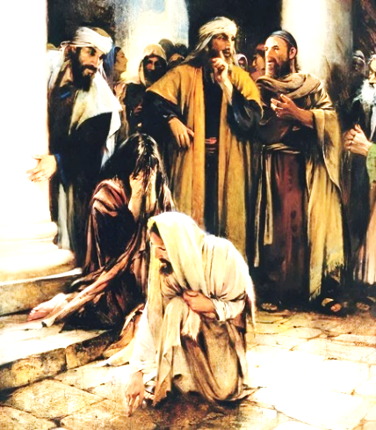*Jesus went to the Mount of Olives. At daybreak he appeared in the Temple again; and as all the people came to him, he sat down and began to teach them.*

*The scribes and Pharisees brought a woman along* ***who had been caught committing adultery****; and making her* ***stand there in full view of everybody****, they said to Jesus, ‘Master, this woman was caught in the very act of committing adultery,* ***and Moses has ordered us in the Law to condemn women like this to death by stoning.*** *What have you to say?’ They asked him this as a test, looking for something to use against him. But* ***Jesus bent down and started writing on the ground with his finger.*** *As they persisted with their question, he looked up and said, ‘If there is one of you who has not sinned, let him be the first to throw a stone at her.’ Then he bent down and wrote on the ground again. When they heard this they went away one by one, beginning with the eldest, until Jesus was left alone with the woman, who remained standing there. He looked up and said, ‘Woman, where are they? Has no one condemned you?’ ‘No one, sir’ she replied.* ***‘Neither do I condemn you,’ said Jesus ‘go away, and do not sin anymore.’***

**In Summary**

**This gospel combines the themes that have been emerging during Lent: the goodness and mercy of God and the need for repentance.** It is an interesting exercise to concentrate on the woman in this story. She is dragged in by the religious authorities to be used as a ‘thing’ to test Jesus. In this early phase of the encounter, Jesus does not look at the woman or acknowledge her presence but addresses his response to the crowd and to the scribes and Pharisees. It is only after they have left the scene in shame that he turns his attention to the woman and establishes personal contact with her, confirming that she is a human person and not a ‘thing’. The intimacy of his address to her as ‘Woman’ echoes the term he uses in addressing his mother (John 2:4, John 19:26). **Jesus neither condemns nor condones. He simply accepts the woman as she is and invites her to a new life. It is acceptance and love that allows repentance and change to occur in others.** *(The Summit Online at: www.melbournecatholic.org)*

**In Conclusion**

The question posed to Jesus by the Pharisees was meant to trick Him. If Jesus condoned the stoning of the lady, then it would be contrary to Roman law; if Jesus refused to condone it, then He would be holding Jewish religious law in contempt. Jesus does not condemn the sinner but **invites her to leave her past behind and begin again:** ***‘Neither do I condemn you,’ said Jesus ‘go away, and do not sin anymore.’***

The Law. ***“….and Moses has ordered us in the Law to condemn women like this to death by stoning.”*** However, the Law they refer to, makes it clear that both parties should be punished. **Since the man is missing, the scribes and Pharisees have themselves not followed the law and sinned.**

But What was Jesus Writing?? What was Jesus “***writing on the ground with his finger.”*** Christian scholars through the ages have speculated various subjects, like: **“***when Jesus wrote on the ground with His finger, He was harkening back to the time on Mt Sinai when He had written the Ten Commandments on stone tablets with His finger (St Augustine);* or, *that Jesus was recording the sins of the scribes and Pharisees.* It is a mystery why John included this detail in the passage, yet, did not describe, nor, explain what was written. The significance may be in Jesus’ actions (when be bent down and wrote on the ground) rather than words which He may (or may not) have written.

**Jesus has been preaching that God is merciful and forgiving, and patient for our repentance (like in last week’s parable of the prodigal son). Yet, the scribes and Pharisees in the temple, do the opposite – they condemn the woman and seek to punish her (*death by stoning).*** *S*o (*perhaps*),Jesus showed His disdain and disapproval, by disassociating Himself from the scribes and Pharisees in the temple: **“*Jesus bent down and started writing on the ground with his finger****,”* however, **Jesus did not abandon the sinner** (the woman).

**Unlike the scribes and Pharisees,** **Jesus was merciful and did not abandon, nor, condemn the woman (a sinner). God loves us and is merciful (*Jesus’ parable of the prodigal son – 4th Sunday in Lent gospel*), and, God is patient (and hopeful) and wants us to bear “good fruit” (*Jesus’ parable of the fig tree – 3rd Sunday in Lent gospel*).**

*Meanwhile in the Holy Land, the ruins of ancient buildings have stone/paved floors, which are often decorated with mosaic (some of which are still visible today).*

**Thursday 07th April – St Peregrine Healing Mass**

A healing Mass in honour of St Peregrine, Patron Saint of cancer sufferers and helper of all in need, will be **at the Willetton Catholic Parish, on Thursday 07th April, at 7pm.** **There will be blessing with the Relic of St Peregrine.** This healing Mass is for all those suffering from serious illnesses, as well as, for their loved ones who care for them.

**Parish Lenten Program**

**The virtues of prayer, fasting and almsgiving are at the heart of our Lenten experience**. Through **prayer** we are drawn closer to God so that we are better able to realise our baptismal promise to live as Jesus teaches us. **Fasting** joins us in solidarity with the poor who often have no choice but to live without food. **Almsgiving** is a sign of our commitment to others and our compassion. **During Lent, we remember our vows to reject sin and to be disciples of Jesus.**

|  |  |
| --- | --- |
| **DATE** | **EVENT & TIME (PC = Project Compassion)** |
| **03rd April** | 5th Sun of Lent. **PC: In Solomon Islands.** *Caritas Australia helps the young with education, as well as, training for adult employment.* |
| **10th April** | **PASSION/PALM Sunday. PC:** *2022 Project Compassion donations are to be used to help ensure a better future for the needy.* |
| **14th April** | **HOLY THURSDAY**  **6.00 pm Washing of the Feet & Last Supper** |
| **15th April** | **GOOD FRIDAY** *Special collection for our Holy Land*  **Stations of the Cross 10am**  **The Passion of Christ 3pm** |
| **16th April** | **HOLY SATURDAY**  **“Lighting the Easter Fire/Candle.”** |
| **17th April** | **EASTER SUNDAY 9.30am** |

***Note: Stations of the Cross Every Friday at 6pm during Lent and 10am on Good Friday***

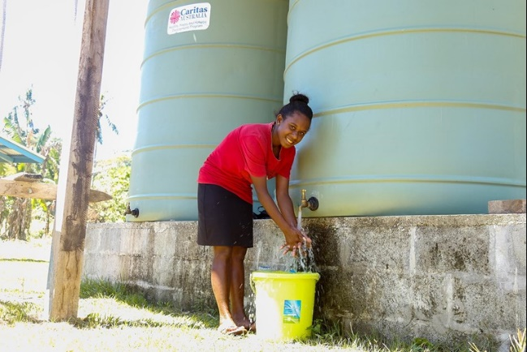**2022 Project Compassion Week Five – Helping People in the Solomon Islands**

Shaniella grew up in a remote village in the Solomon Islands – one of the country’s poorest. She moved closer to Honiara, to study hospitality and tourism. However, her vocational training school was hit by a landslide and cyclone in quick succession, destroying its water supply system and the vegetable garden that it relies on for food. **Caritas Australia** Solomon Islands (CASI) was able to help the school to install eight water tanks. This restored students’ access to clean drinking water and the tanks also supply water to nearby schools, health centres and the wider community. CASI also provided planting materials, 200 chickens, and training in agricultural skills and poultry management, to help it to boost its food security.

**Our Parish Worship Schedule** A parish is a community of disciples of Jesus, who gather to celebrate the Mass and to “live the Gospel.” **We are a community of Jesus’ disciples** **and our church is here for our collective and individual worship and prayers.** We welcome the faithful to our Mass, or, to light a candle at our Marian chapel, or, to just pray in silence; and to grow spiritually.

**Mass Times** Mon, Tue, Wed, Thu & Fri 8.00 am (the Rosary after)

Saturday 6.00 pm

**Mass Times**  Sunday 9.30 am

**Reconciliation** Saturday night 5.15 – 5.45 pm

**Anointing of the Sick** Liaise with Fr Greg

**Baptisms, marriages and funerals** Liaise with Fr Greg

**Our Prayers of the Faithful**

In our parish prayers of the faithful, we pray to the Lord, to help and comfort our sick and suffering. We also pray for the souls of our recently departed, as well as, for those whose anniversaries, we remember at Mass today.

**Prayers for Our Sick and Suffering**

Crowley family**,** Joe Sundaram, Thilak, Diana Scully, Bluey Thompson**,** Celeste Vicensoni, Michael D’Souza, Glen Langan, Carla, Annette, Joe Gibson**,** Georgina and Ronnie Ghosh, Gemma Altieri, Fred Kara, Reg Brown, Mary & Derrick Jansen, Marie Webster Viola, Gerry and Maisie Prendergast, James Rydqvist, Annie Magdalena Rydqvist, Anne Rydqvist, Dr Andrew Chilufya Snr, Robbie Iliffe, Claire Webster, Donna Green, Horatio Hill, Vernon Thompson, Ilean Wright, Elham Nejaty, Cathy and Peter Ghouse, Jimmy Olivero, Kaye McIntyre, Alvin Desker, Jess Cable, Jeff and Tony Francis, Fr Andre, Sheila Vanwieringan, CD Joseph, Marina Lim, Joseph Fernandes, Wendy Price, Julie Pinto, Christopher Jaffer, Yianni Donato, Bonnie Sullivan, Joslyn De Sylva and Philomena Rodrigues.

**Prayers for our Recently Departed**

**Terry Hogben and Glyn Ashley.**

***“God blesses those people who grieve. They will find comfort.”* (Matthew 5:4).**

**Anniversaries of our Beloved Deceased**

Kenny Boswell (31 Mar), Carmen Barros Vega (01 Apr), Nora and Norman Boswell (02 Apr), Drina Leeson (03 Apr), Bruno Vicensoni (05 Apr), Epifanio Marciano (06 Apr), Zena Batchelor (06 Apr) and all our departed relatives and friends.

**“God loved the world so much he gave us his only Son, so that everyone who believes in him may not be lost but may have eternal life” (John 3:16).**

*Note: Parishioners may email Cliff at:* [*cliffordgerard@bigpond.com*](mailto:cliffordgerard@bigpond.com)*, for any additions (or deletions) to our lists of sick, recently deceased and anniversaries, whom you wish to be included in our “Prayers of the Faithful.”* ***Everyone has a name and if we are to pray for them - we should say their name.***

**Our Parish St Vincent de Paul (SVDP) Food Donations Today**

***Food donations may be left at the rear of the church (a box is situated for small items/donations), or, in the parish centre. Cash donations may be deposited in the poor box at the door. Every donation helps SVDP to help the needy in our local communities.***

Parishioners who may need a “helping hand,” may contact the SVDP Society for assistance, or, speak with our local SVDP representatives: **Bruno George (mobile: 0470571041**) at Wilson Parish, or **Sister Charla (telephone: 93545083)** at Riverton Parish. **The names of those requesting and receiving assistance is always confidential*.***