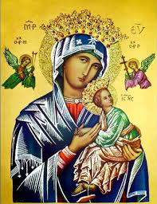**Our Lady of Perpetual Help Parish**

14 Castledare Place, Wilson 6107. **Telephone:** 9258 6003

**Email:** [Wilson@perthcatholic.org.au](mailto:Wilson@perthcatholic.org.au)

**Website:** www.wilsoncatholicchurch.org

**Parish Priest:** Reverend Father Greg D’Almeida.

**Email:**[gregory.dalmeida@perthcatholic.org.au](mailto:gregory.dalmeida@perthcatholic.org.au)

**Presbytery Telephone:** 9458 6586

**Parish Council and Rosters:** Lorraein O’Callaghan-Munt.

**Mobile Number:** 0417942854 **Email:** [Munt.pandL8@bigpond.com](mailto:Munt.pandL8@bigpond.com)

**Parish Safeguarding Officers:** Toto Olita and Rob Marshall

**Parish Newsletter:** Cliff Nunes**. Email:** cliffordgerard@bigpond.com

**The Solemnity of the Most Holy Body and Blood of Christ.**

**Year C. 19th June 2022**

***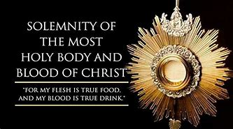* Gospel: John 16: 12-15**

***Jesus made the crowds welcome*** *and talked to them about the kingdom of God; and he cured those who were in need of healing.*

*It was late afternoon when the Twelve came to him and said, ‘Send the people away, and they can go to the villages and farms round about to find lodging and food; for we are in a lonely place here.’ He replied, ‘Give them something to eat yourselves.’ But they said, ‘We have no more than five loaves and two fish, unless we are to go ourselves and buy food for all these people.’ For there were about five thousand men. But he said to his disciples, ‘Get them to sit down in parties of about fifty.’ They did so and made them all sit down.* ***Then he took the five loaves and the two fish, raised his eyes to heaven, and said the blessing over them; then he broke them and handed them to his disciples to distribute among the crowd****. They all ate as much as they wanted, and when the scraps remaining were collected they filled twelve baskets.*

**In Summary**

The feeding of 5000, was instigated by the disciples - they wanted Jesus to send the crowd away, however, Jesus decides to feed the crowd. **This miracle of the Multiplication of Bread and Fish, is a forerunner to the institution of the Eucharist at the Last Supper - Jesus takes bread, looks up to heaven, blesses the bread, breaks it, and then gives it to the disciples to distribute (and to nourish the crowd).**

**Supplementary to Today’s Gospel**

**The twelve baskets** full of remaining food signify that the Eucharist can meet all our needs. The abundance of the Eucharist is enough, indeed more than enough, to sustain us spiritually.

Just as **“*Jesus made the crowds welcome”* - all who come seeking Christ will be nourished**. As Jesus said in His last instruction to Peter before His Ascension: *“feed my lambs...tend my sheep…****feed my sheep****.”***We are the sheep (part of God’s flock) and to feed is to nourish spiritually (the Eucharist).**

**Jesus came as the “*Lamb of God*”** to give His body and blood for our salvation. At Holy Communion, we all become part of Jesus’ body when we receive the Eucharist. **In the Eucharist, we are therefore in communion with the Lord and each other.**

**This is the mystery** **that is at the heart of the Eucharist.** The elements of bread and wine, become Jesus’ Body and Blood (transubstantiation). When we share in the Body and Blood of Christ, Jesus Himself comes to dwell within us. This communion with the Lord, will nourish and fortify us to live a “gospel life,” on our journey to heaven.

**In Conclusion**

Jesus said to them, **"I tell you the truth, unless you eat the flesh of the Son of Man and drink his blood, you have no life in you. Whoever eats my flesh and drinks my blood has eternal life, and I will raise him up at the last day."**

**We have Holy Communion because** **the Lord told us to:** And when he had given thanks, He broke it and said, **"This is my body, which is for you; *do this*in remembrance of me."**

**Receiving Holy Communion and the General Instruction of the Roman Missal May 07**

**160.** The priest then takes the paten or ciborium and goes to the communicants who, as a rule, approach in a procession. The faithful are not permitted to take the consecrated Bread or the sacred chalice by themselves and, still less, to hand them from one to another. In Australia standing is the most common posture for receiving Holy Communion. The customary manner of reception is recommended to be followed by all, so that Communion may truly be a sign of unity among those who share in the same table of the Lord. **When approaching to receive Holy Communion, the faithful bow in reverence of the Mystery that they are to receive.**

**Jesus Shows Us His Presence in 150 Eucharistic Miracles**

Over the centuries, our Lord has shown us that He is truly present in the Blessed Sacrament (the Holy Eucharist). **God reveals Himself to help our faith because He desires to prove that what He said is true,** as the Scripture says:

“***The Lord confirmed the word with signs that followed*"** (Mark 16:16). As Jesus says: ***"Though you will not believe Me, believe the work,”*** as, **“*They give testimony of Me"*** (John 10:38). Transubstantiation, is when our gifts (of bread and wine) are converted into the flesh and blood of Jesus Christ at Mass. **Many Eucharistic miracles show the Host is “turned into human flesh and blood.”**

Faith, of course, should not be based on miracles alone. Several of the recorded miracles are very old, and it may be possible to dismiss them. However, the reports of these miracles have strengthened the faith of many at the time and provided belief of the miracle, that takes place at Mass, when bread and wine are transubstantiated into the body and blood of Christ.

The Vatican has verified about 150 Eucharistic Miracles from the 3rd Century until today. **In the last 25 years, the Vatican has venerated and verified no less than six Eucharistic Miracles:**

Buenos Aires Eucharistic Miracle in **Argentina** 1996

Cua Eucharistic Miracle in **Venezuela** 1991/1998

Chirattakonam: Eucharistic Miracle in **India**, 2001

Tixtla: Eucharistic Miracle in **Mexico**, 2006

Sokolka: Eucharistic Miracle in **Poland**, 2008

Legnica: Eucharistic Miracle in **Poland**, 2013

These “recent” Eucharistic Miracles have occurred, at a time that science and medicine have advanced enough, to thoroughly investigate (to prove, or, to refute) these consecrated hosts, which suddenly turn blood red, and even take the form of flesh.

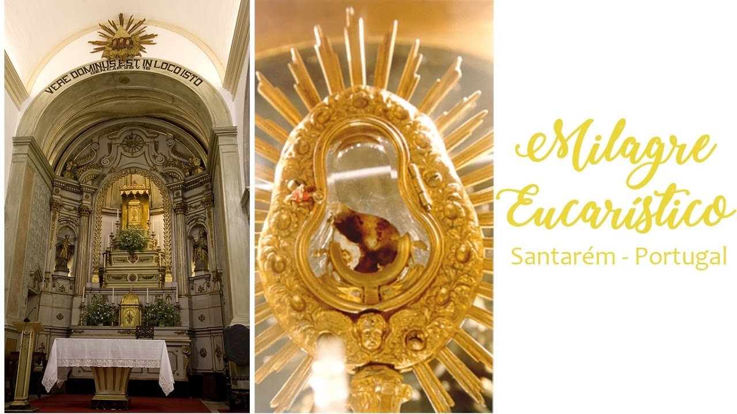

**Scientific Results**

Each of these “recent” revelations have received intensive study with highly advanced technology. In several cases, these were “blind” investigations when doctors/scientists did not know the source of the material. **Yet, in all the cases (when samples were possible) the same results were found:**

1. **The blood examined is human,** **AB blood type.** Human DNA was found; white blood cells, red blood cells, hemoglobin, and mycrophages were present, indicating fresh blood. **In the Tixtla miracle (in Mexico),** the blood clearly emanated from within, because the blood on the surface had begun to coagulate but the interior blood was still fresh, as with a bleeding wound.
2. **The flesh examined is human myocardium tissue** of the left ventricle of an inflamed heart. **In the miracles from Argentina (18th August 1996) and Poland**, there are evidence of trauma from the presence of thrombi, indicating repeated lack of oxygen; lesions present showed rapid cardiac spasms typical in the final phases of death.
3. **In the Sokolka miracle (in Poland),** the remaining host is tightly interconnected with the fibers of human tissue, penetrating each other inseparably – as if **the bread were transforming into flesh**. “Even NASA scientists, who have at their disposal the most modern analytical techniques, would not be able to artificially recreate such a thing,” affirmed Dr Sobaniec-Lotowska, one of the examining experts.

**Note:**

1. Dr Frederick Zugibe, a forensic doctor at Columbia University who examined the Argentinian miracle did not know the source of the sample and told the doctor who brought it to him: “If white blood cells were present (in the heart tissue), it is because **at the moment you brought me the sample, it was pulsating**.” When he learned the source of the sample, he was shocked and deeply moved.
2. **The most recent scientific examination of the Shroud of Turin has dated the shroud as about 2,000 years old and the blood stains on the shroud as - AB blood type**.

***Meanwhile in Portugal****, on the road to Fatima, we stopped at the Church of St Stephen (a small stone church no larger than ours), in the village of Santarem. There above the Tabernacle, we viewed the* ***Eucharistic Miracle of Santarem*** *– the consecrated Host which has changed into bleeding flesh and blood of our Lord. The blood appeared to me, to be no different to coagulated blood which would appear on a wound a few hours after injury, yet, the blood, flesh and host, have been on display for veneration since 1247 (almost 780 years). These days I bow to the Lord before I receive the Holy Eucharist at Communion.*

**Our Parish Worship Schedule** A parish is a community of disciples of Jesus, who gather to celebrate the Mass and to “live the Gospel.” **We are a community of Jesus’ disciples** **and our church is here for our collective and individual worship and prayers.** We welcome the faithful to our Mass, or, to light a candle at our Marian chapel, or, to just pray in silence; and to grow spiritually.

**Mass Times** Mon, Tue, Wed, Thu & Fri 8.00 am (the Rosary after)

Saturday 6.00 pm

**Mass Times**  Sunday 9.30 am

**Reconciliation** Saturday night 5.15 – 5.45 pm

**Anointing of the Sick** Liaise with Fr Greg

**Baptisms, marriages and funerals** Liaise with Fr Greg

**Our Prayers of the Faithful**

In our parish prayers of the faithful, we pray to the Lord, to help and comfort our sick and suffering. We also pray for the souls of our recently departed, as well as, for those whose anniversaries, we remember at Mass today.

**Prayers for Our Sick and Suffering**

Maria Marshall, Claire Webster**,** Ivan Fletcher, Fabian Edmunds, Celia, Crowley family**,** Joe Sundaram, Thilak, Diana Scully, Bluey Thompson**,** Celeste Vicensoni, Michael D’Souza, Carla, Annette, Joe Gibson**,** Georgina and Ronnie Ghosh, Gemma Altieri, Fred Kara, Reg Brown, Mary & Derrick Jansen, Marie Webster Viola, Gerry and Maisie Prendergast, James Rydqvist, Annie Magdalena Rydqvist, Anne Rydqvist, Dr Andrew Chilufya Snr, Robbie Iliffe, Donna Green, Horatio Hill, Ilean Wright, Elham Nejaty, Cathy and Peter Ghouse, Jimmy Olivero, Kaye McIntyre, Alvin Desker, Jess Cable, Jeff and Tony Francis, Fr Andre, Sheila Vanwieringan, CD Joseph, Marina Lim, Joseph Fernandes, Wendy Price, Julie Pinto, Christopher Jaffer, Yianni Donato, Bonnie Sullivan, Joslyn De Sylva and Philomena Rodrigues.

**Prayers for our Recently Departed**

**John Cova,** Phyllis Falk, Gopi Panickar, Sandra Young,Matthew Antony, Annamma Antony and Vernon Thompson.

**Anniversaries of our Beloved Departed**

Howard Norris (16 Jun), Escolastico Labos (17 Jun), Charmaine Aviet (20 Jun), Louise Chong (20 Jun) and Andrew Munt (20 Jun) and all our departed relatives and friends.

***Note:*** *Parishioners may email Cliff at:* [*cliffordgerard@bigpond.com*](mailto:cliffordgerard@bigpond.com)*, for any additions (or deletions) to our lists of sick, recently deceased and anniversaries, whom you wish to be included in our “Prayers of the Faithful.” Thank-you.*

***Everyone has a name, and if we are to pray for them, we should say their name.***