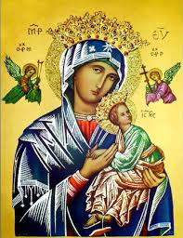**Our Lady of Perpetual Help Parish**

14 Castledare Place, Wilson 6107. **Telephone:** 9258 6003

**Email:** [Wilson@perthcatholic.org.au](mailto:Wilson@perthcatholic.org.au)

**Website:** www.wilsoncatholicchurch.org

**Parish Priest:** Reverend Father Greg D’Almeida.

**Email:**[gregory.dalmeida@perthcatholic.org.au](mailto:gregory.dalmeida@perthcatholic.org.au)

**Presbytery Telephone:** 9458 6586

**Parish Council and Rosters:** Lorraein O’Callaghan-Munt.

**Mobile Number:** 0417942854 **Email:** [Munt.pandL8@bigpond.com](mailto:Munt.pandL8@bigpond.com)

**Parish Safeguarding Officers:** Toto Olita and Rob Marshall

**Parish Newsletter:** Cliff Nunes**. Email:** cliffordgerard@bigpond.com

**Holy Trinity Sunday. Year C. 12th June 2022**

**Gospel: John 16: 12-15**

*I still have many things to say to you but they would be too much for you to bear now.* *However,* ***when the***[***Spirit***](https://www.catholic.org/encyclopedia/view.php?id=11004)***of***[***truth***](https://www.catholic.org/encyclopedia/view.php?id=11728)***comes he***[***will***](https://www.catholic.org/encyclopedia/view.php?id=12332)***lead you to the complete truth, since he***[***will***](https://www.catholic.org/encyclopedia/view.php?id=12332)***not be speaking of his own accord,******but***[***will***](https://www.catholic.org/encyclopedia/view.php?id=12332)***say only what he has been told; and he***[***will***](https://www.catholic.org/encyclopedia/view.php?id=12332)***reveal to you the things to come.******He***[***will***](https://www.catholic.org/encyclopedia/view.php?id=12332)***glorify me, since all he reveals to you***[***will***](https://www.catholic.org/encyclopedia/view.php?id=12332)***be taken from what is mine.*** ***Everything the Father has is mine; that is why I said: all he reveals to you***[***will***](https://www.catholic.org/encyclopedia/view.php?id=12332)***be taken from what is mine.***

**In Summary**

This short gospel has two parts: Jesus reinforces His previous promise that an advocate/counsellor – ***“the Spirit of Truth will be sent to lead you to the complete truth,”*** but **Jesus also reveals the three persons of the Trinity: Himself, the Father and the Holy Spirit, – this is the mystery of the Holy Trinity** and this feast of the Solemnity of the Most Holy Trinity, invites us to consider what we believe about **God**, who has revealed Himself to us in **the Holy Trinity— three persons in one God – each equal but different.**

**Background on the Gospel Reading**

Today's Gospel comes near the end of Jesus' address to the disciples at the Last Supper. In last week’s gospel Jesus assures the disciples that an advocate/counsellor will be sent to help them (as we saw last week at Pentecost). Even though Jesus must leave the disciples, He tells them that they will have a future because of the help He will send to them - ***the Spirit of Truth***.

Jesus also provides a brief but concise explanation of the Trinity. Although the idea of one God in three persons remains a mystery, we have the assurance, that Jesus and the Father share all, as well as, that Jesus and the Spirit share “the Word.”

**The Holy Trinity is three persons in one God – God the Father, God the Son and God the Holy Spirit. All three are equally divine, with different divine roles in God’s plan; and only God, will decide the way and the means, by which He will reveal Himself.**

**The Council of Chalcedon and the Doctrine of the Trinity (AD 451)**

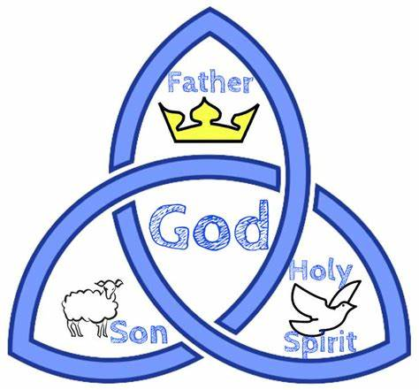From earliest times the Church has pondered the relationship between the Father, Son and Holy Spirit. **The Doctrine of the Trinity, most eloquently defined at the Council of Chalcedon as:** **three persons in one God**, is the result of this. The Council of Chalcedon, was the fourth ecumenical council of the Christian Church, and was held in Chalcedon in 451. It was attended by about 520 bishops (or their representatives) and was the largest and best-documented of the early councils.

Note: The mystery of the Most Holy Trinity is the central mystery of Christian faith and life. It is the mystery of God in himself. It is therefore the source of all the other mysteries of faith, the light that enlightens them. It is the most fundamental and essential teaching in the "hierarchy of the truths of faith". The whole history of salvation is identical with the history of the way and the means by which the one true God, Father, Son and Holy Spirit, reveals himself to men "and reconciles and unites with himself those who turn away from sin". (*Catechism of the Catholic Church 234*).

**An Epiphany of the Holy Trinity at Jesus’ Baptism**

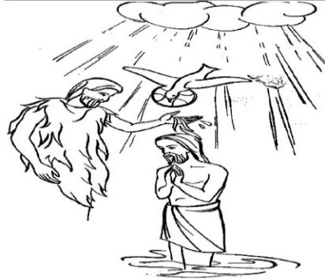In addition to the Epiphany of Christ, the baptism of Jesus at the Jordan River, is also an epiphany of the Holy Trinity. At the Jordan River, at that moment, at the baptism of Jesus, we have the manifestation of the Holy Trinity – Father, Son and the Holy Spirit:

The voice from heaven is of **God the Father,** ***“You are my Son, the Beloved; with you I am well pleased;”***

Jesus the**Son of God** is present;and

the **Holy Spirit** manifests like a dove - **“*and the Spirit descending like a dove on Him.”***

***This is an Epiphany of the Holy Trinity – here we have the worldly manifestation/revelation of the one true God as three persons - the Father, the Son and the Holy Spirit, at the same place, at the same time – the three persons in one God is the truth!!!!!***

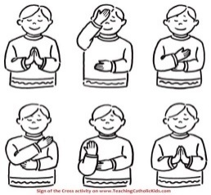**Our Most Holy Trinity Prayer - The Sign of the Cross**

Many of the prayers of the Church express our belief in a

Triune God (three persons in one God). One of the greatest

prayers is the Sign of the Cross, where we dedicate ourselves

***‘In the name of the Father, Son and Holy Spirit’*.** This trinity is enshrined in the Nicene Creed: **“*We believe in one God, the Father the Almighty ... We believe in one Lord, Jesus Christ ... We believe in the Holy Spirit ...”***

**Another Prayer to the Holy Trinity**

***“Glory be to the Father, and to the Son and to the Holy Spirit. As it was in the beginning, is now and ever shall be, world without end. Amen”***

**The Legend of St Patrick, the Trinity and the Shamrock**

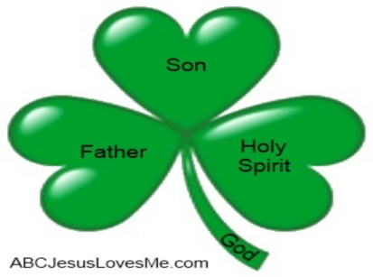One day a group of St Patrick’s followers came to him and admitted that it was difficult for them to believe in the doctrine of the Holy Trinity. St. Patrick reflected a moment and then, stooping down, he plucked a leaf from the shamrock and held it before them, bidding them to behold the living example of the "Three-in-One." St. Patrick used the shamrock to explain the concept of the Holy Trinity of the Father, the Son, and the Holy Spirit. **He explained how the three leaves are part of the one plant, and how similarly the three Persons, Father, Son, and Spirit, are part of one Supreme Being.**

**Our Parish Worship Schedule** A parish is a community of disciples of Jesus, who gather to celebrate the Mass and to “live the Gospel.” **We are a community of Jesus’ disciples** **and our church is here for our collective and individual worship and prayers.** We welcome the faithful to our Mass, or, to light a candle at our Marian chapel, or, to just pray in silence; and to grow spiritually.

**Mass Times** Mon, Tue, Wed, Thu & Fri 8.00 am (the Rosary after)

Saturday 6.00 pm

**Mass Times**  Sunday 9.30 am

**Reconciliation** Saturday night 5.15 – 5.45 pm

**Anointing of the Sick** Liaise with Fr Greg

**Baptisms, marriages and funerals** Liaise with Fr Greg

**Our Prayers of the Faithful**

In our parish prayers of the faithful, we pray to the Lord, to help and comfort our sick and suffering. We also pray for the souls of our recently departed, as well as, for those whose anniversaries, we remember at Mass today.

**Prayers for Our Sick and Suffering**

**Maria Marshall, Claire Webster,** Ivan Fletcher, Fabian Edmunds, Celia, Crowley family**,** Joe Sundaram, Thilak, Diana Scully, Bluey Thompson**,** Celeste Vicensoni, Michael D’Souza, Carla, Annette, Joe Gibson**,** Georgina and Ronnie Ghosh, Gemma Altieri, Fred Kara, Reg Brown, Mary & Derrick Jansen, Marie Webster Viola, Gerry and Maisie Prendergast, James Rydqvist, Annie Magdalena Rydqvist, Anne Rydqvist, Dr Andrew Chilufya Snr, Robbie Iliffe, Donna Green, Horatio Hill, Ilean Wright, Elham Nejaty, Cathy and Peter Ghouse, Jimmy Olivero, Kaye McIntyre, Alvin Desker, Jess Cable, Jeff and Tony Francis, Fr Andre, Sheila Vanwieringan, CD Joseph, Marina Lim, Joseph Fernandes, Wendy Price, Julie Pinto, Christopher Jaffer, Yianni Donato, Bonnie Sullivan, Joslyn De Sylva and Philomena Rodrigues.

**Prayers for our Recently Departed**

**Gopi Panickar, Sandra Young,** Matthew Antony, Annamma Antony**,** Vernon Thompson, Kerry Wimbridge, Glen Langan, Eugene Marie and Felice Palumbo.

**Anniversaries of our Beloved Departed**

Leo Wybrott (09 Jun), Bernard D’Souza (11 Jun), John O’Mahony (12 Jun), Patricia Stephenson (14 Jun) and all our departed relatives and friends.

***Jesus assured Martha at the tomb of Lazarus: “I am the Resurrection and the life; whoever believes in Me will live even though he dies”*** *(John 11: 25-26).*

***Note:*** *Parishioners may email Cliff at:* [*cliffordgerard@bigpond.com*](mailto:cliffordgerard@bigpond.com)*, for any additions (or deletions) to our lists of sick, recently deceased and anniversaries, whom you wish to be included in our “Prayers of the Faithful.” Thank-you.*

***Everyone has a name, and if we are to pray for them, we should say their name.***

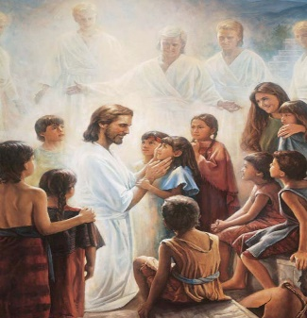**We Welcome “God’s Little Children” to Our Mass**

*People were bringing little children to Jesus to have him touch them, but the disciples rebuked them. When Jesus saw this, he was indignant. He* *said to them,* ***“Let the little children come to me, and do not hinder them, for the kingdom of God belongs to such as these.”***Mk 10: 13-14.

Activity sheets and colour pencils, are available at the rear of the church, to occupy the children during Mass. Parents may even pin their child’s work on the noticeboard (when space is available) for others to appreciate their efforts.

**Weekend 02nd /03rd July is Our Next Parish St Vincent de Paul Donations**

Parishioners who may need a “helping hand,” may contact the SVDP Society for assistance, or, speak with our local SVDP representatives: **Bruno George (mobile: 0470571041**) at Wilson Parish, or **Sister Charla (telephone: 93545083)** at Riverton Parish. **The names of those requesting and receiving assistance is always confidential*.***

**Congratulations to Two Dear Parishioners**

***On Friday 10th June 2022, Lorna and Austin Johnstone have been married for 63 years. In addition, Lorna is 83 years old on Saturday 11th June.***

***Our best wishes to you, from everyone at Wilson Parish. May God keep you in His loving embrace!!!***

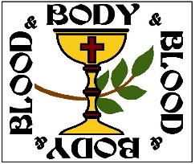

**Next Week is the Solemnity of the Most Holy Body and Blood of Christ**

The Solemnity of the Most Holy Body and Blood of Christ, was called *Corpus Christi* (Latin for the Body of Christ). However, the name for this day was expanded (to the Most Holy Body and Blood of Christ) to be a more complete reflection of our Eucharistic theology.